LAB 12
Exception Handling
Lab Task:
Write a program that meets the following requirements:
• Creates an array with 10 randomly chosen integers.
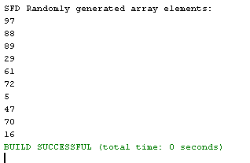
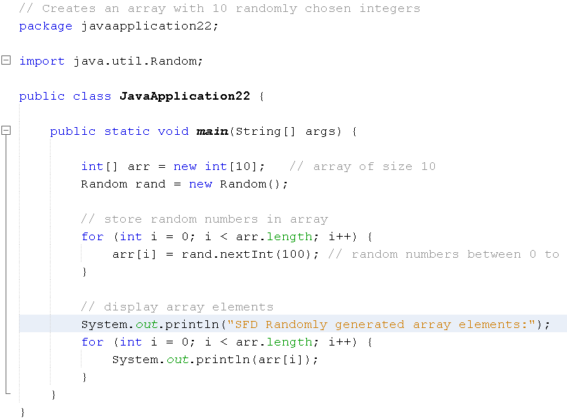
• Prompts the user to enter the index of the array, then displays the corresponding element
value. If the specified index is out of bounds, display the message Out of Bounds.
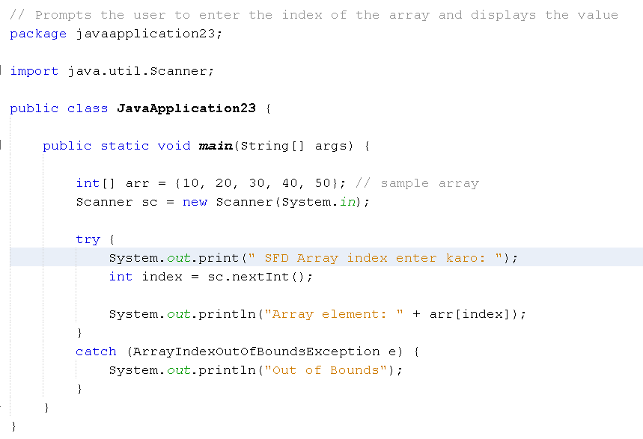
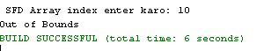
Suppose you are developing a game for kids in which they are learning the division operation in math. Your game will take input from kids (2 integers) and then perform the division and displays the answer. Think and apply exception handling in this scenario. For e.g. Arithmetic Exception might occur here. Also suppose, this game has the limitation that it only performs division between integers so if it gets a decimal number as input, it throws an exception stating that the input is invalid, please give integer number etc

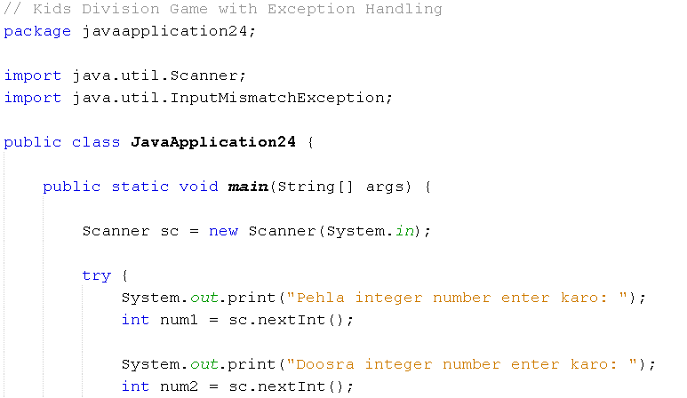
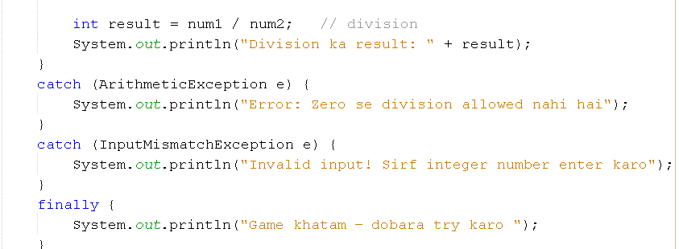
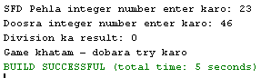

LAB#13
ABSTRACT DATA TYPES
OBJECTIVE: Understanding and implementing abstract data types
LAB TASK:
Considering a bank interface, it will have different concrete classes for receiving bill payments,
opening of new accounts and contacting those loan takers whose limits of extension have been
expired. Now, develop this scenario on the described ADT and decide which ADT should be
used for each concrete class, also implement the whole scenario in multiple java classes
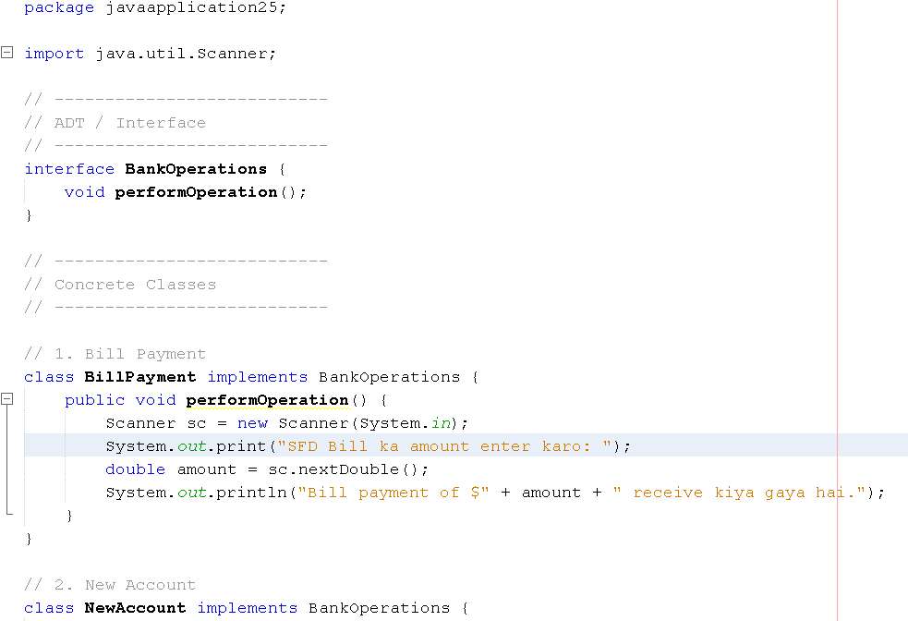
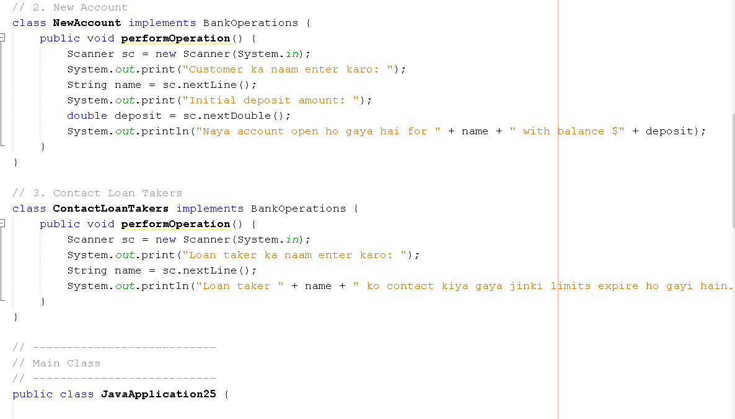

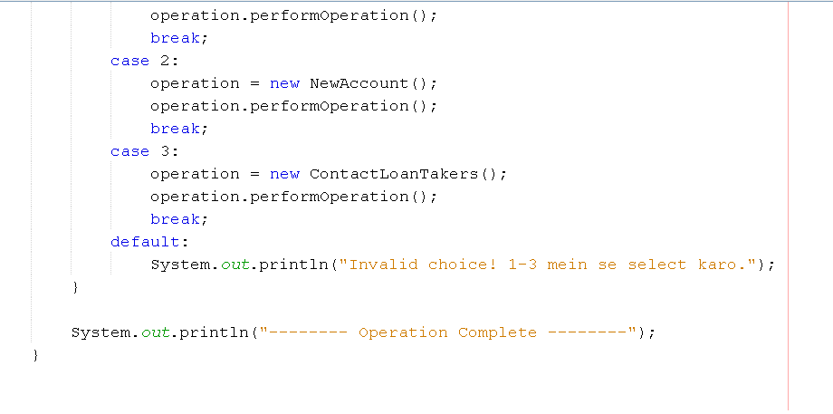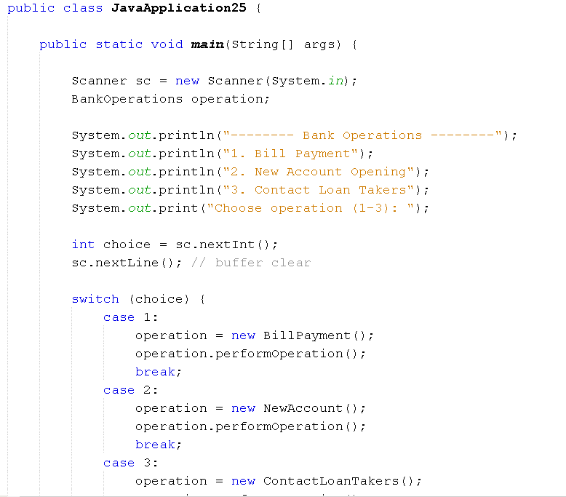
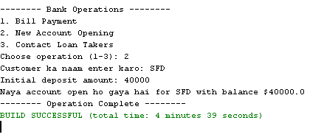
LAB # 14
Mutability and Immutability
1 Apply concept of mutability and immutability for the task promoted and failed students.The roll number, subject code, and subject name would have to be entered at time ofobject creation and with getter method these variables should be printed. (Hint: Thosestudents who are failed in previous semester will be registered in immutable class, andpromoted students are registered in mutable class)
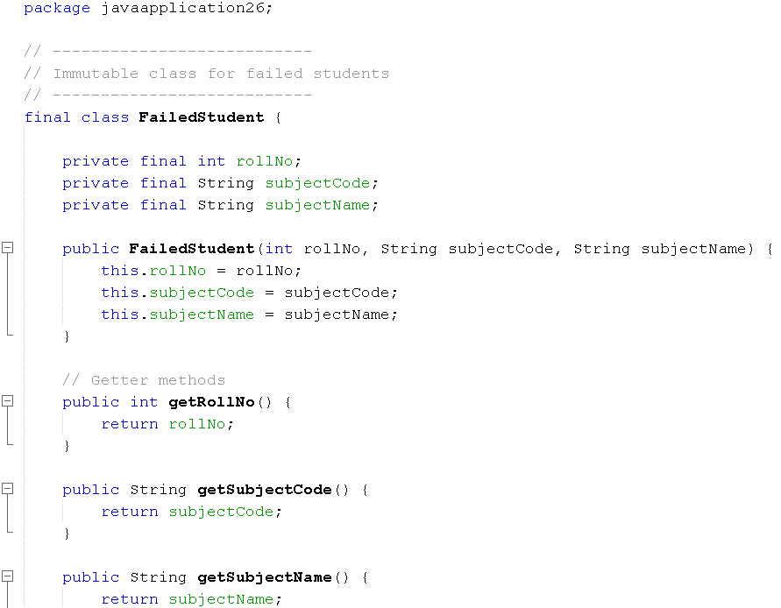
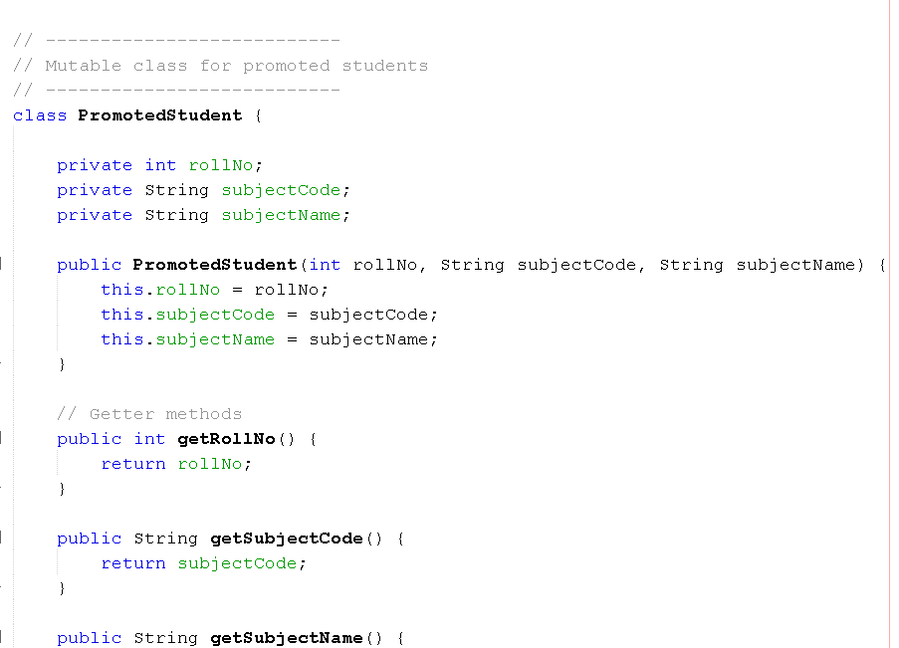
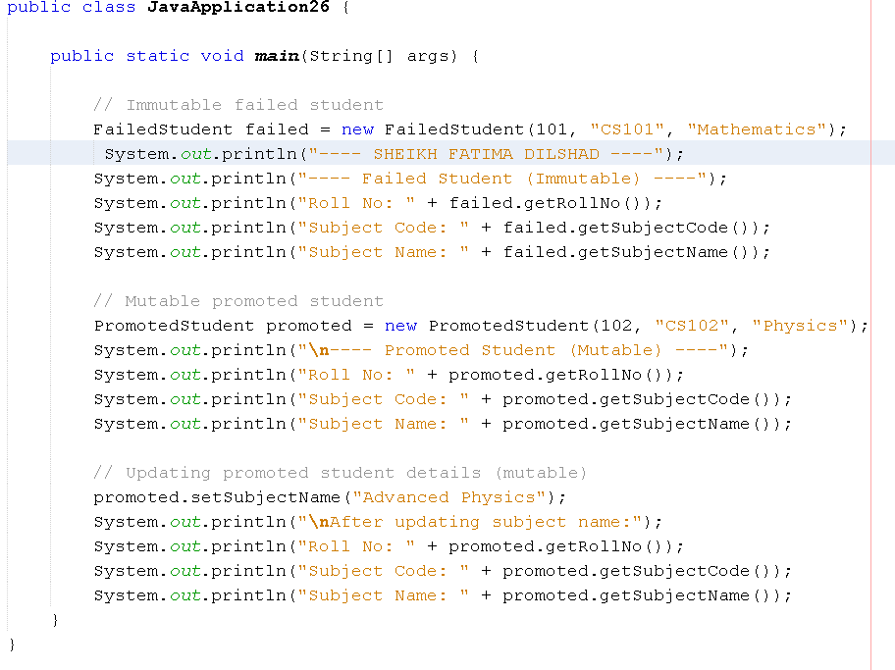
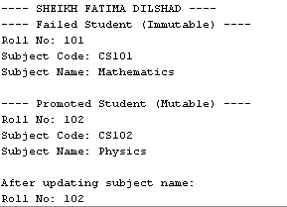
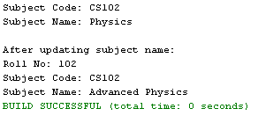

2 Write a program that will calculate the below 4 formulas. Decide what to make mutable
and what to make immutable and perform task operations. Formulas are:
Circumference of circle: C = 2 π r Area of circle: A = π r² Volume of sphere: V = 4/3 π r3 Surface area of sphere: A = 4 π r²
(Hint: Value of would be constant and value of radius should be variant)
